Microsoft Excel as a Financial Calculator

Excel can be used for various mathematical calculations, especially the time value of money calculations. There is more of a learning curve than a regular financial calculator, but it is much more powerful. This tutorial will demonstrate how to use Excel's financial functions to handle basic time value of money problems using the same examples as in the HP 10BII calculator tutorial. If you already understand the basics of using Excel, this tutorial will help you to understand the financial functions.

Analogy to Calculator Financial Keys
All financial calculators have five financial keys, and Excel's basic time value functions are exactly analogous. The table below shows the equivalency between the calculator keys and Excel functions:
Purpose | Calculator Key | Excel Function
Solve for  Number of Periods | N | NPer(rate, pmt, pv, fv, type)
Solve for  periodic interest rate | I/Yr | Rate(nper,pmt,pv,fv,type,guess)
Solve for  present value | PV | PV(rate,nper,pmt,fv,type)
Solve for  annuity payment | PMT | PMT(rate,nper,pv,fv,type)
Solve for  future value | FV | FV(rate,nper,pmt,pv,type)

Just as you have to supply four of the variables to solve a TVM problem in a financial calculator, you also have to supply four of the arguments to each Excel function. Note that in the table, the bold function arguments are required while those in italics are optional.


You don't need to memorize the order of the function arguments. You can use the Insert Function dialog box, which will prompt your for the arguments by name. Or, if you prefer to type the function directly, Excel will display a Smart Tag that shows the order of the arguments as you type.
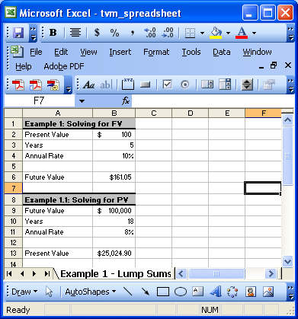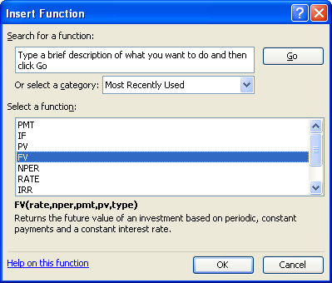
Function Key
Function Dialog Box

Example 1 – Solving for Future Value
We'll begin with a very simple problem that will provide you with most of the skills to perform financial math using Microsoft Excel:

Suppose that you have $100 to invest for a period of 5 years at an interest rate of 10% per year. How much will you have accumulated at the end of this time period?

In this problem, the $100 is the present value (PV), NPer is 5, and Rate is 10%. Open a new workbook and enter the data as shown below, but leave B5 blank for now.
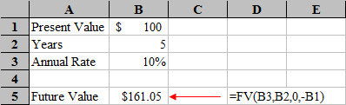
To find the future value of this lump sum investment we will use the FV function, which is defined as:
FV(rate,nper,pmt,pv,type)

Select cell B5 and then type: =FV(B3,B2,0,-B1) and then press Enter. The answer that you get should be 161.05.

A Couple of Notes
- Every time value of money problem has either 4 or 5 variables (corresponding to the 5 basic financial variables). Of these, you will always be given 3 or 4 and asked to solve for the other. In this case, we have a 4-variable problem and were given 3 of them (Nper, Rate, and PV) and had to solve for the 4th (FV). Be sure that any variables not in the problem are set to 0, otherwise they will be included in the calculation. In this case, we did not have a payment (PMT), so the third argument in the FV function was set to 0.
- Note that we left out the optional Type argument. In all of these functions, the Type argument tells Excel when the first cash flow occurs (0 if at the end of the period, 1 if at the beginning). This argument is identical to setting your financial calculator to End Mode or Begin Mode, and only affects the answer when there is an annuity payment. For each of our calculations, we will always be using the end of the period, soothe Type argument should either be zero (0) or leave blank.
- Note that, unlike most financial calculators, there is no argument to set the compounding frequency. In Excel functions, you must set NPer to be the total number of periods, Rate to be the interest rate per period, and PMT to be the annuity payment per period. So, if this problem had said that the compounding was monthly (annual was implied), then we would have typed =FV(B3/12,B2*12,0,-B1).
- Note that our interest rate (in B3) was entered into that cell as 0.10 (or, you could type 10%). This is different than financial calculators. In a calculator, your interest rate would be entered as 10 instead of 0.10. The calculator automatically divides the number entered into the interest rate by 100. Excel makes no adjustment to Rate, so you must enter it as a decimal. Had you entered 10 (without the percent sign) into B3, the future value would have come out to $16,105,100 — obviously incorrect. That's because Excel would think that your interest rate was 1,000% per year.
- Notice that we entered -B1 (-100) for the PV argument in the function. Most financial calculators (and spreadsheets) follow the Cash Flow Sign Convention. This is simply a way of keeping the direction of the cash flow straight. Cash inflows are entered as positive numbers and cash outflows are entered as negative numbers. In this problem, the $100 was an investment (i.e., a cash outflow) and the future value of $161.05 would be a cash inflow in five years. Had you entered the $100 as a positive number no harm would have been done, but the answer would have been returned as a negative number. This would be correct had you borrowed $100 today (cash inflow) and agreed to repay $161.05 (cash outflow) in five years.
- We can change any of the variables in this problem without needing to re-enter all of the data. For example, suppose that we wanted to find out the future value if we left the money invested for 10 years instead of 5. Simply change B2 to 10, and you'll find that the answer in B5 is 259.37.
- Please note that it is important that you always use cell references in your formulas. Never type a number directly into any formulas or Excel functions (unless that number will never change). If you do type numbers into formulas, then you will have to remember to change each formula that relies on that number or else you will get errors. The best practice is to always have an "input area" somewhere on your worksheet that contains all of the variables. Then, each formula or function that you use will get its values by referencing cells in the input area. (Note that this was not followed in #3, above. That was for ease of explanation. You should add a row with the label "Compounding" and put the 12 in there instead.)

Example 2 — Solving for Present Value
Solving for the present value of a lump sum is nearly identical to solving for the future value, except that we use the PV function. Let's try a new problem:

Suppose that you are planning to send your child to college in 18 years. Furthermore, assume that you have determined that you will need $100,000 at that time in order to pay for tuition, room and board, party supplies, etc. If you believe that you can earn an average annual rate of return of 8% per year, how much money would you need to invest today as a lump sum to achieve your goal?

In this case, we already know the future value ($100,000), the number of periods (18 years), and the per period interest rate (8% per year). We want to find the present value. Create a worksheet like the one below:
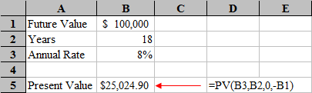
We need to use the PV function, which is defined as:
PV(rate,nper,pmt,fv,type)
So, select B5 and enter the formula: =PV(B3,B2,0,-B1) and see that you would need to invest $25,025 today to fund your child's future education. Alternatively, if you are willing to take on considerably more risk then you might be able to earn, say, 11% per year. If you change the value in B3 to 11%, then you can see that you would only have to invest $15,282.22.

Example 3 — Solving for the Number of Periods
Sometimes you know how much money you have now, and how much you need to have at an undetermined future time period. If you know the interest rate, then you can solve for the amount of time that it will take for the present value to grow to the future value by solving for N.
Suppose that you have $1,250 today and you would like to know how long it will take you double your money to $2,500. Assume that you can earn 9% per year on your investment.

As the name suggests, this function is designed to solve for the number of periods and is defined as:
NPer(rate, pmt, pv, fv, type)
Create a new worksheet and enter the data shown below:
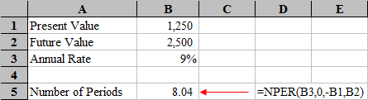
Select B5 and type: =NPER(B3,0,-B1,B2). You can see that it will take 8.04 years to double your money. One important thing to note is that you absolutely must enter your PV and FV according to the cash flow sign convention. If you don't make either the PV or FV a negative number (and the other one positive), then you will get a #NUM error instead of the answer. That is because, if both numbers are positive, Excel thinks that you are getting a benefit without making any investment. If you get this error, just fix the problem by changing the sign of either PV or FV. In this problem it doesn't really matter which one is negative. The key is that they must have opposite signs.

Example 4 — Solving for the Interest Rate
Solving for the interest rate is quite common. Maybe you have recently sold an investment and would like to know what your compound average annual rate of return was. Or, perhaps you are thinking of making an investment and you would like to know what rate of return you need to earn to reach a certain future value. Let's return to our college savings problem from above, but we'll change it slightly.
Suppose that you are planning to send your child to college in 18 years. Furthermore, assume that you have determined that you will need $100,000 at that time in order to pay for tuition, room and board, party supplies, etc. If you have $20,000 to invest today, what compound average annual rate of return do you need to earn in order to reach your goal?

Finding the interest rate in a time value of money problem requires the use of the Rate function, which is defined as:
Rate(nper,pmt,pv,fv,type,guess)
Note that the Guess argument is rarely required and is optional. In most cases, you can just leave it out. It is included for those times (only when dealing with annuities) when there are two or more solutions to the problem. Typically, this only happens when you are dealing with uneven cash flows and there are sign changes in the cash flow stream. It can occasionally happen in annuity problems, when the FV has a different sign than PMT.
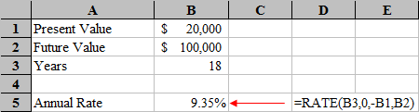
Create a new worksheet and enter the data as shown above. Select B5 and enter the Rate function: =RATE(B3,0,-B1,B2). As before, we need to be careful when entering the PV and FV into the function. In this case, you are going to invest $20,000 today (a cash outflow) and receive $100,000 in 18 years (a cash inflow). Therefore, we entered -20,000 for PV, and 100,000 into FV. Again, if you get #NUM instead of an answer, it is because you didn't follow the cash flow sign convention.

Note that in our original problem we assumed that you would earn 8% per year, and found that you would need to invest about $25,000 to achieve your goal. In this case, though, we assumed that you started with only $20,000. Therefore, in order to reach the same goal, you would need to earn a higher interest rate.

Example 5 — Solving for the Payment Amount
We often need to solve for annuity payments. For example, you might want to know how much a mortgage or auto loan payment will be. Let's look at our college savings problem again, but this time we'll treat it as an annuity problem instead of a lump sum:

Suppose that you are planning to send your child to college in 18 years. Furthermore, assume that you have determined that you will need $100,000 at that time in order to pay for tuition, room and board, etc. If you believe that you can earn an average annual rate of return of 8% per year, how much money would you need to invest at the end of each year to achieve your goal?

Recall that we previously determined that if you were to make a lump sum investment today, you would have to invest $25,024.90. That is quite a chunk of change. In this case, saving for college will be easier because we are going to spread the investment over 18 years, rather than all at once. (Note that, for now, we are assuming that the first investment will be made one year from now.)
Open a new worksheet and enter the data as shown below:
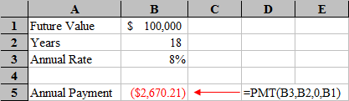
In this problem we want to solve for an annual annuity payment, so we will use the PMT function. Select B5 and enter: =PMT(B3,B2,0,B1). Note that we entered 0 for the PV argument because the problem doesn't specify an initial investment. You will find that you need to invest $2,670.21 per year for the next 18 years to meet your goal of having $100,000.

Now, let's change the problem slightly where we have a PV investment made today:

Suppose that you have just received a gift from one of your child’s grandparents. They have given you $5,000 to be invested to help pay for her college tuition. How does this change the amount that you would have to invest each year?

Since you will now be investing $5,000 today (the PV), the amount that you need to save in future years will be reduced. To find out the new annual payment that is required, we need to modify the spreadsheet somewhat. First, select Row 1 and insert a new row. Now, in A1 type: Present Value and in B1 enter: 5,000.
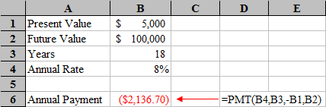
Finally, we need to change the formula in B6 to: =PMT(B4,B3,-B1,B2). Notice that the PV argument has been changed from 0 to -B1. It has to be entered as a negative number because the $5,000 will be invested (a cash outflow). If you had put it in as a positive number, then you would get the wrong answer ($3,203.72). You should catch this error because the result is higher than if you didn't have the $5,000 to invest. Again, you always have to think about the direction of the cash flows when using these functions.

Final Notes

When you have solved a problem, always be sure to give the answer a second look and be sure that it seems likely to be correct. This requires that you understand the calculations that the functions are doing and the relationships between the variables. If you don't, you will quickly learn that if you enter wrong numbers you will get wrong answers. Remember, Excel only knows what you tell it, it doesn't know what you really meant.

You may choose to use the function dialog box instead of typing in the variables manually. This may be more user-friendly because Excel guides you for what variables are needed. To do so, follow these steps:
- First, click in the cell where you want to generate your answer.
- Click the function button in the menu bar at the top.
Function Key

- When the dialog box appears, you must select the formula you need to calculate the missing TVM variable. Once you have selected the formula to use, click OK.
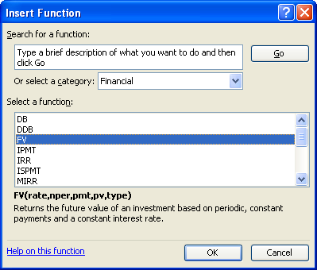Note that you may need to search for the formula you need by selecting the Financial category from the drop down box.

- When you select OK, another dialog box will appear, prompting you to enter data for each variable. This dialog box will be lightly different depending upon which variable for which you are solving. For example, if you were solving for the FV, the dialog box will look like this:
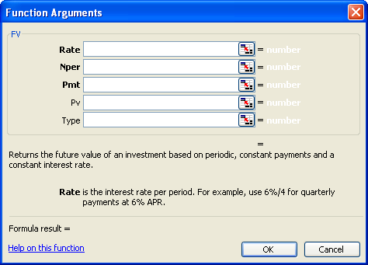

- You must then input the data for each variable. You may use either numerical data or the cell references containing the specific numeric data.

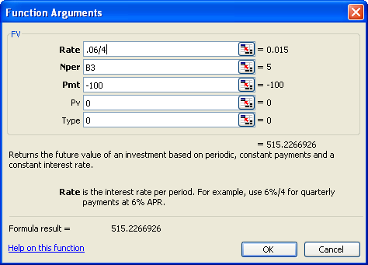

Note that when click in each space, Excel provides you with a helpful tip within the box instructing you how to input data.

The bold items require input. You cannot leave these blank.

Once you have entered all the required data, Excel will provide you with the formula result at the bottom of the dialog box.

- Once you are finished, click OK and your formula result will be entered into the cell which you selected from step 1.

